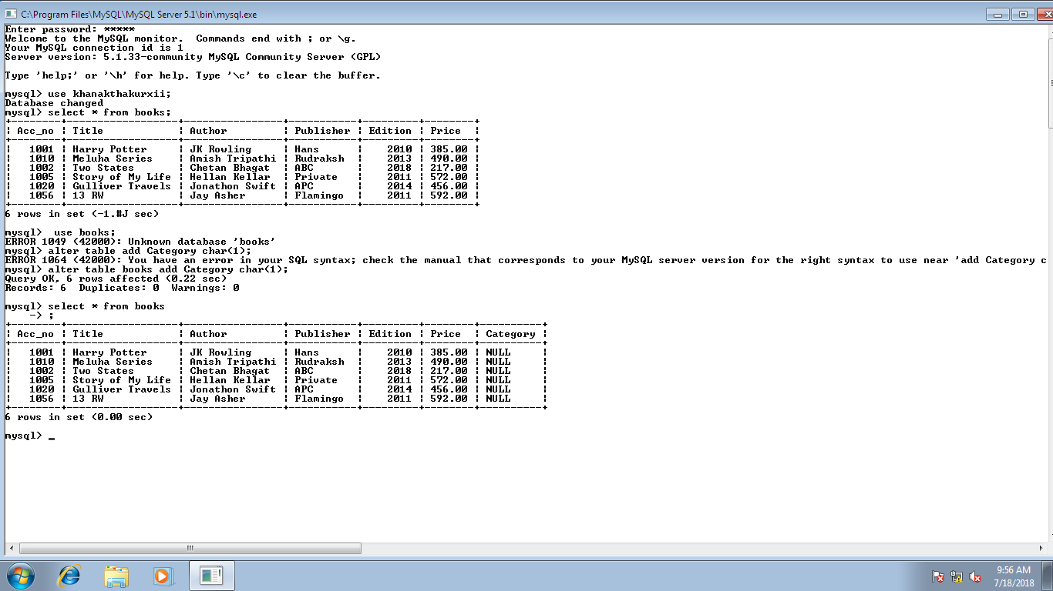**Table: BOOKS**

**QUERIES-**

1. Write the command to create the table.
2. Write the command to list the tables of the database.
3. Write the commands to check if the table has been created.
4. New column category to be added which takes the values as “A”,”B”,”C”.
5. Change the size of column Publisher from 30 characters to 40 characters.
6. Remove category column from table.
7. Insert the following values in the table

1100,”Basic Economics,”J.P.Mudgil”, ”APH”, 2009,200.

1. Check the names without repetition of various publishers whose books are present in the library.
2. Check the books of publisher APH in the library.
3. Display the booklist for which price is between 250 and 500.
4. Display details of books from publishers Hans, APH, ABC.
5. List the Accno, Title, Price of all books whose title contains the word history,
6. Display list of all books in alphabetical ascending order of title.
7. Change publisher of Harry Potter to ABC.
8. Get list in ascending order of publisher followed by descending order of title.

**1**

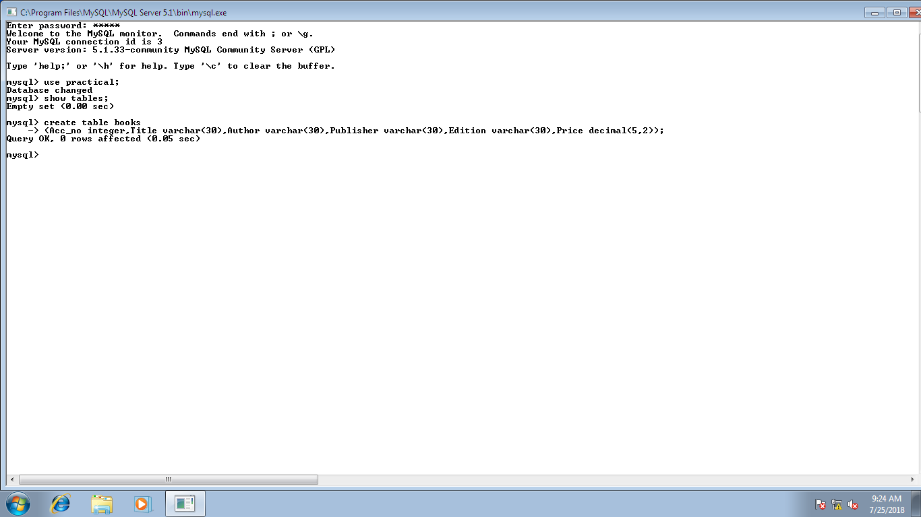

**2**

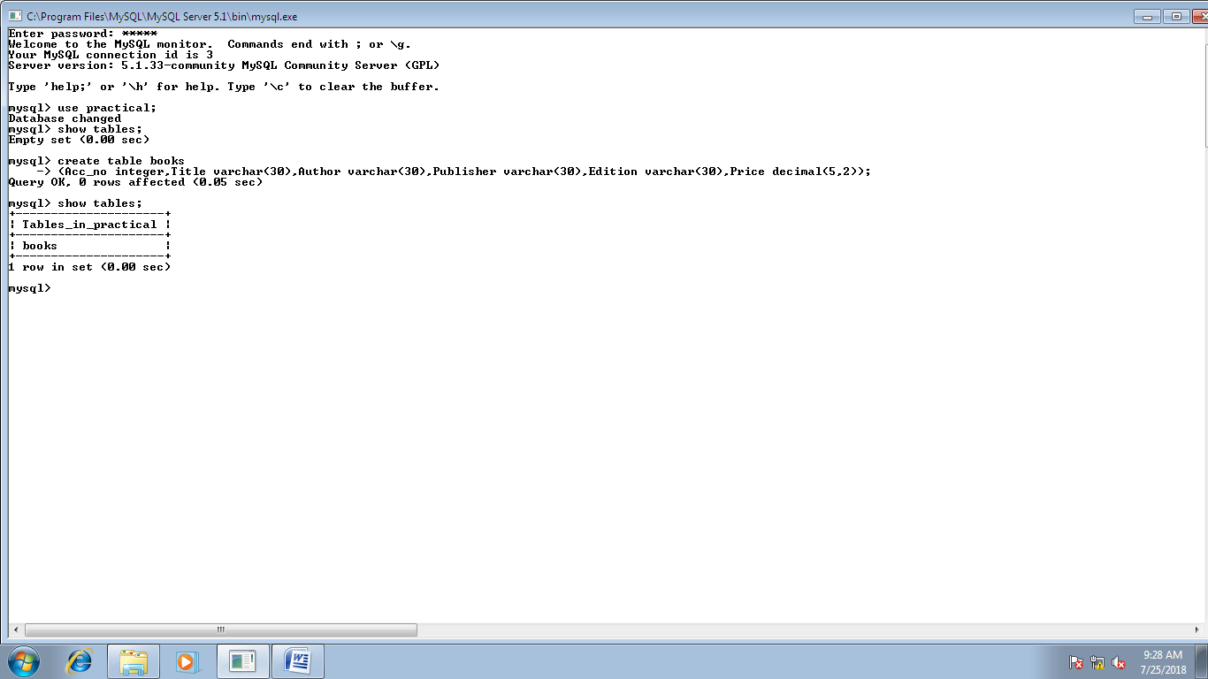

**3**

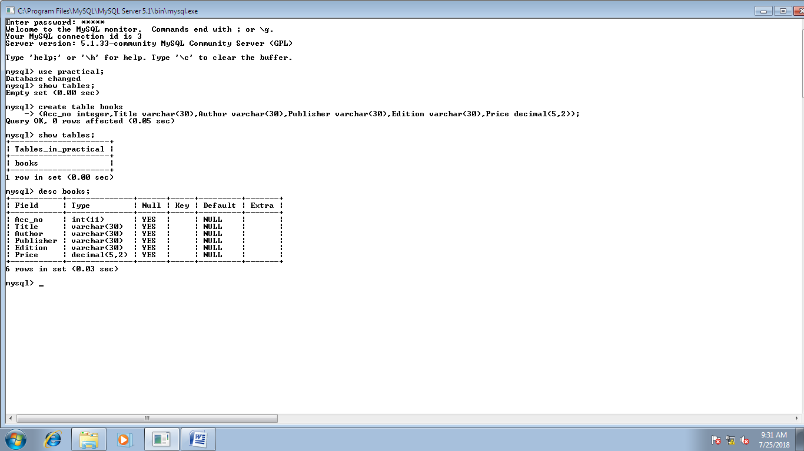

**4**

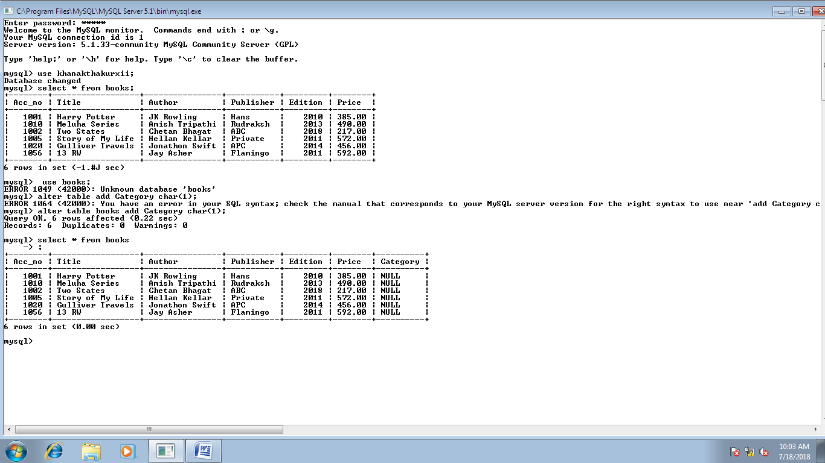



**5**

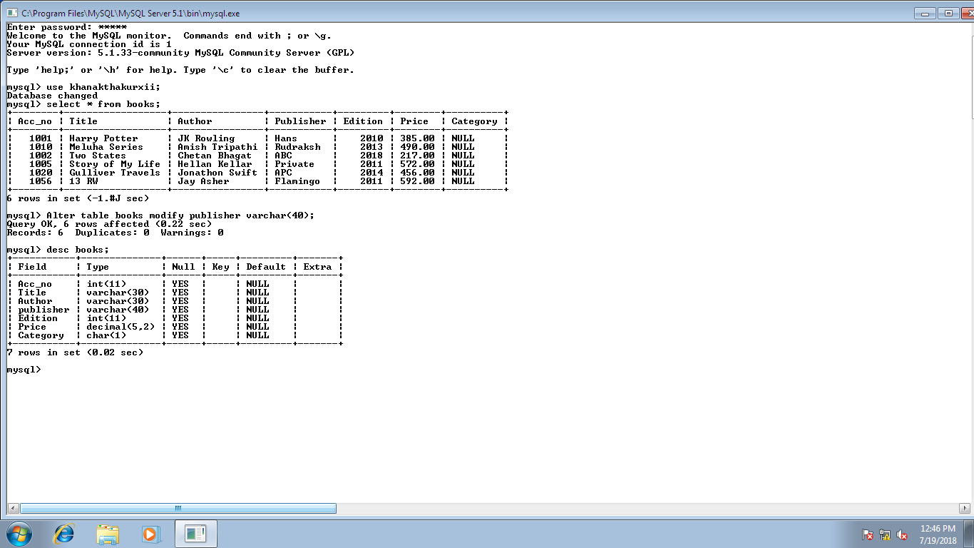

**6**

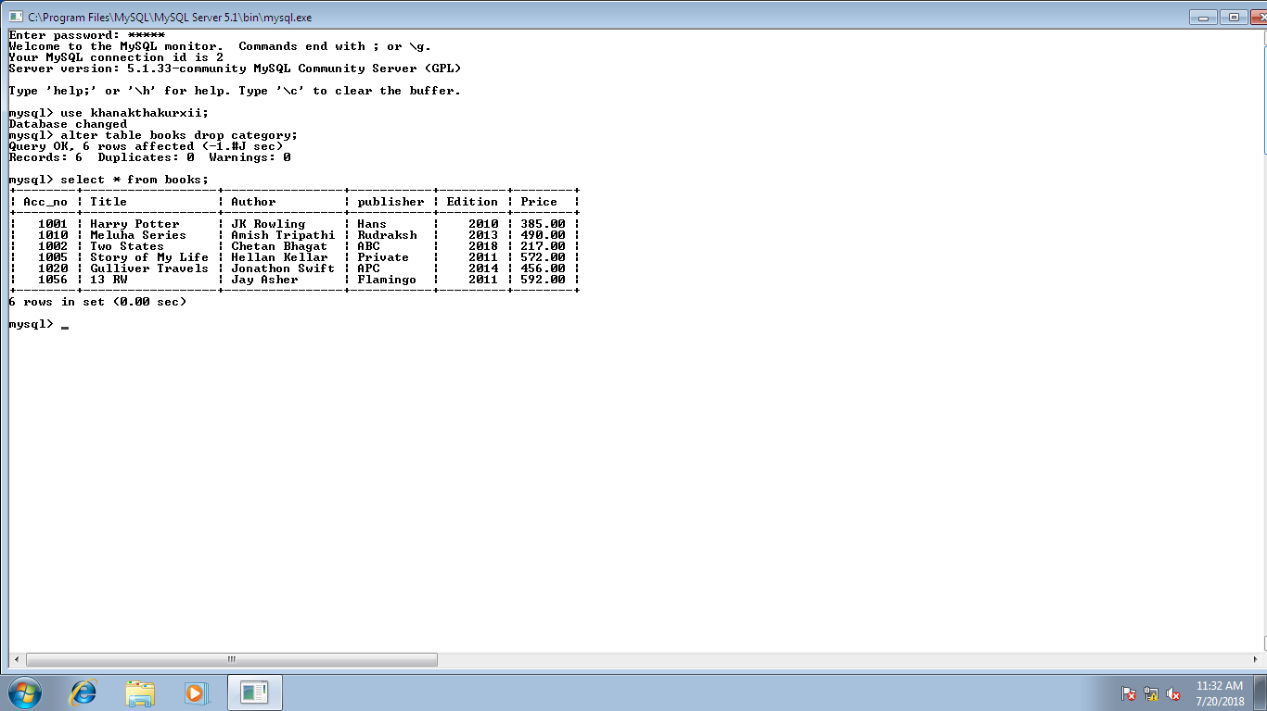

**7**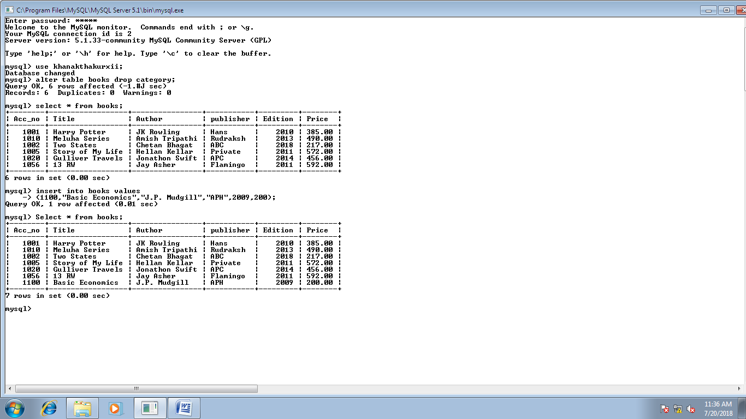

**8**

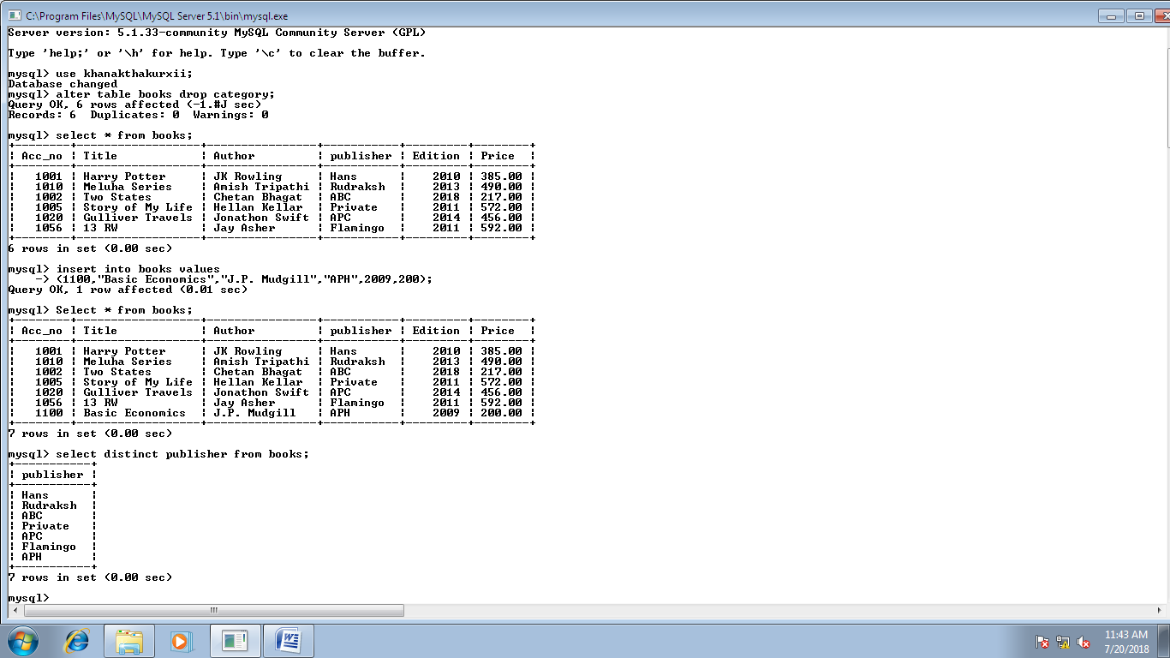

**9**

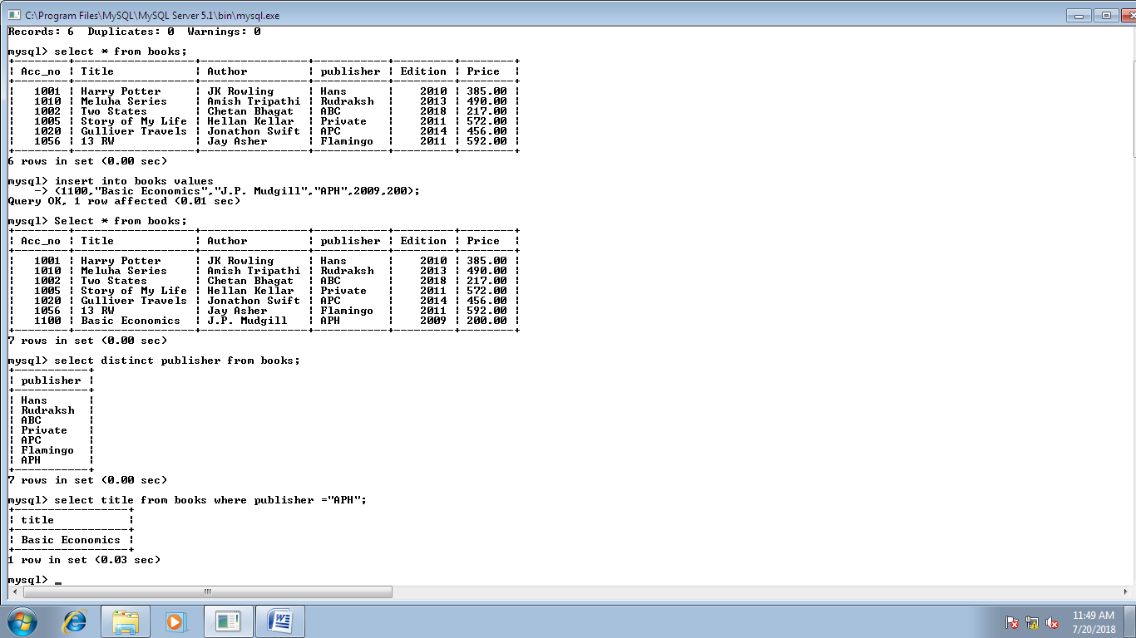

**10**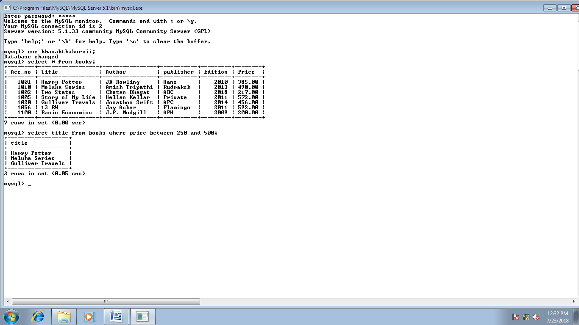

**11**

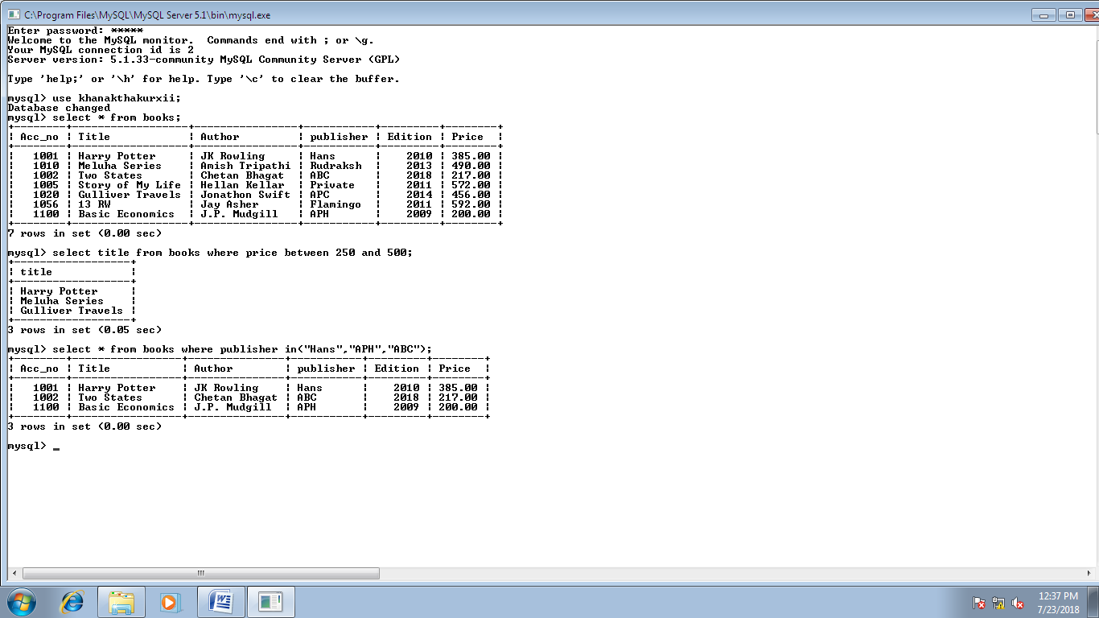

**12**

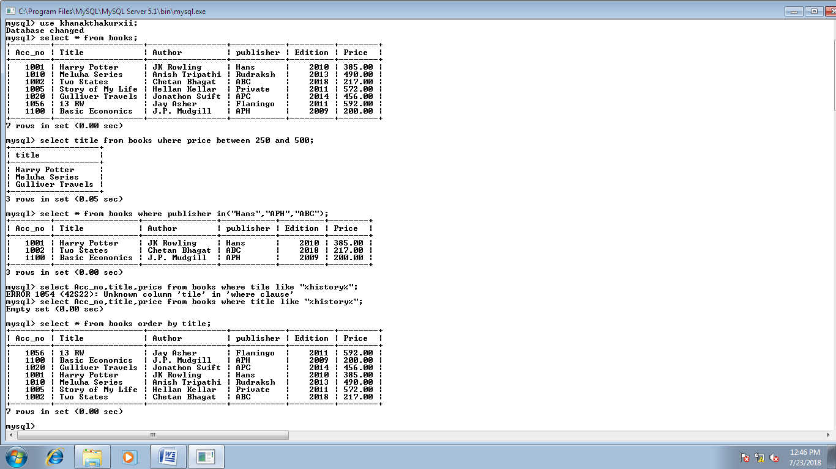

**13**

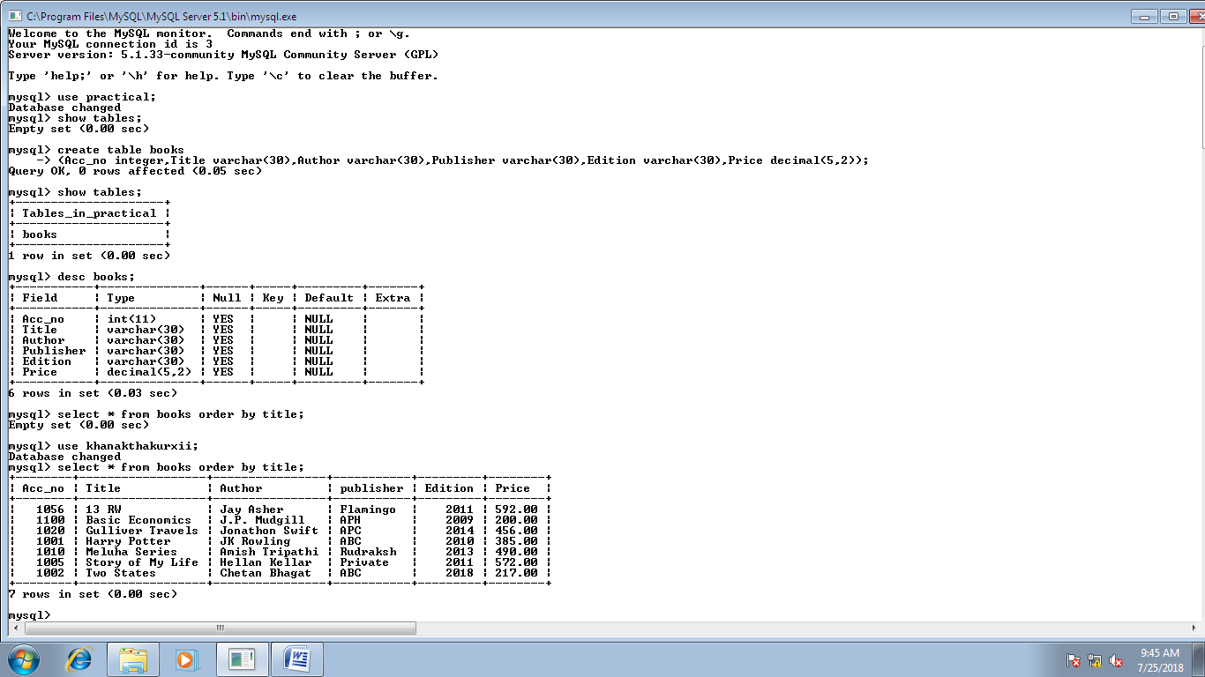

**14**

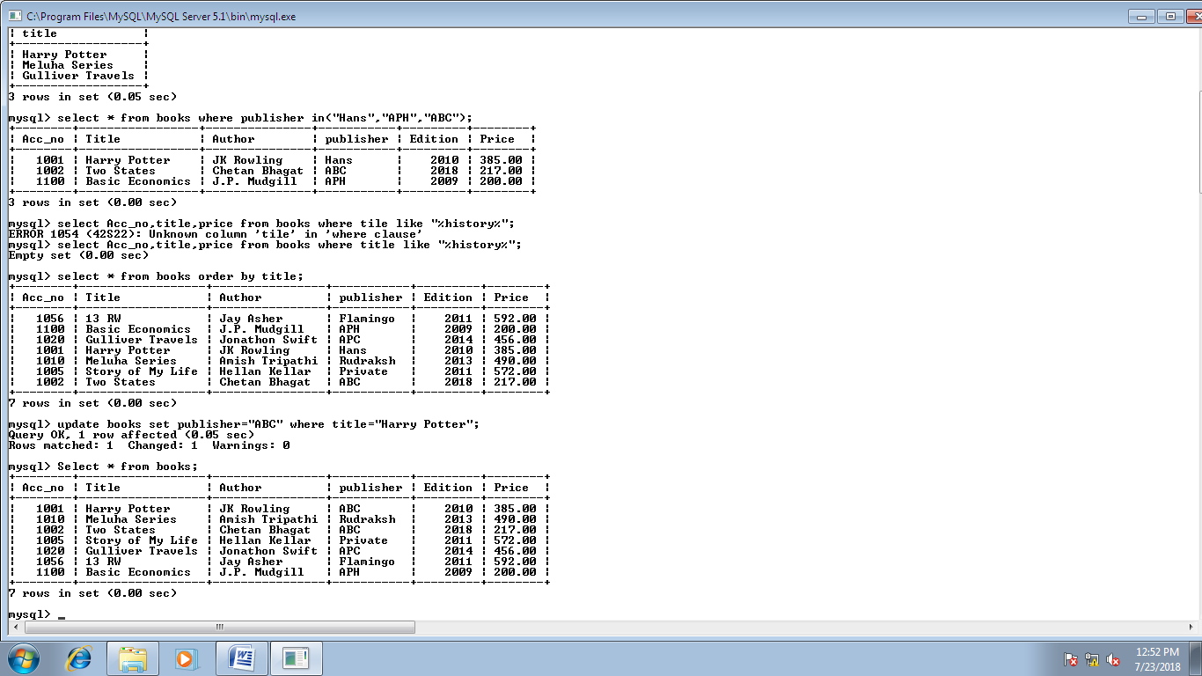

**15**

